Android Source Code Guide

|  |
| --- |
| **Xu Feng** |
| **2014/8/14** |

# Android系统启动过程

<https://www.ibm.com/developerworks/cn/linux/l-linuxboot/>

Linux系统启动

BIOS 固定地址引导程序

--> stage 1 512B加载程序

--> stage2 GRUB

--> 解压内核并运行 Head.s: startup_32

--> start_kernel

--> setup_arch/rest_init/trap_init/init_IRQ

--> kernel_thread --> init

main.c: init

--> do_basic_setup

--> sock_init/do_initcalls

init.c: paging_init

-->pagetable_init

　 physmem.c: init_maps

startup_32

---> decompress_kernel

---> startup_32 (/arch/i386/kernel/head_32.S) <进程 0>

---> i386_start_kernel

---> start_kernel

---> rest_init

---> kernel_thread <进程 1>

---> do_fork

---> kernel_init

---> sys_access

---> init_post

---> run_init_process(ramdisk_execute_command); = '/init'

---> init.rc / init.xx.rc

---> service adbd /sbin/adbd

---> service servicemanager /system/bin/servicemanager

---> service ril-daemon /system/bin/rild

---> service surfaceflinger /system/bin/surfaceflinger

---> service zygote /system/bin/app_process -Xzygote /system/bin --zygote --start-system-server

---> run_init_process(execute_command);

---> run_init_process("/sbin/init");

---> run_init_process("/etc/init");

---> run_init_process("/bin/init");

---> run_init_process("/bin/sh");

---> cpu_idle

Main app_main.c

---> AndroidRuntime::start

---> startVm

---> JNI_CreateJavaVM

---> dvmCreateJNIEnv (malloc JNIEnvExt and insert it to vm->envList)

---> dvmStartup

---> startReg

---> register_jni_procs

---> array[i].mProc(env) = gRegJNI

---> env->CallStaticVoidMethod = ZygoteInit -> Main

ZygoteInit -> Main Zygote启动

---> registerZygoteSocket

---> new LocalServerSocket

---> preload

---> preloadClasses

---> preloadResources

---> preloadOpenGL

---> gc

---> startSystemServer 启动SystemServer

---> Zygote.forkSystemServer

---> nativeForkSystemServer 通过JNI调用native代码

---> Dalvik_dalvik_system_Zygote_forkSystemServer

---> forkAndSpecializeCommon

---> fork()

---> SystemServer.main

---> nativeInit

---> ServerThread.initAndLoop

---> new DisplayManagerService

---> new TelephonyRegistry

---> new PackageManagerService

---> new ServiceManager

---> new BatteryService

---> new VibratorService

---> new WindowManagerService

---> new WifiService 启动WifiService

---> new ConnectivityService 启动ConnectivityService

---> handleSystemServerProcess

---> RuntimeInit.zygoteInit

---> commonInit

---> nativeZygoteInit

---> applicationInit

---> runSelectLoop

---> closeServerSocket

# Android应用启动过程



应用程序进程启动

ActivityManagerService. startProcessLocked

---> Process.start 将启动进程的指令通过socket发送给zygote进程

---> startViaZygote

ZygoteConnection.runOnce

---> Zygote.forkAndSpecialize

--- > nativeForkAndSpecialize = Dalvik_dalvik_system_Zygote_forkAndSpecialize

--- > forkAndSpecializeCommon

--- > fork

--- > setSELinuxContext 设置安全上下文

--- > selinux_android_setcontext

--- > setcon

--- > setprocattrcon

# Binder机制

# AudioFlinger

# MultiMedia框架

# ActivityManagerService之实现

* 1. 启动

SystemServer-> Main systemServer启动

---> thr.initAndLoop

---> ActivityManagerService.main 启动Service

---> thr.start()

---> AThread.run

---> new ActivityManagerService

---> ActivityManagerService.setSystemProcess

---> ServiceManager.addService(Context.ACTIVITY_SERVICE, m, true) 注册Binder

实现详解blog：

<http://blog.csdn.net/yueliangniao1/article/details/7227165>

ActivityManagerService.startActivity

---> ActivityManagerService.startActivityAsUser

---> ActivityStackSupervisor.startActivityMayWait

---> ActivityStackSupervisor.resolveActivity 从packageManager获取launchMode，permission，screenOrientation等信息

---> ActivityStackSupervisor.startActivityLocked

---> ActivityManagerService.checkPermission 验证是否允许启动activity

---> new ActivityRecord 创建ActivityRecord

---> ActivityStackSupervisor. startActivityUncheckedLocked 判断是否要创建新task或者重用已有的task

---> ActivityStackSupervisor .adjustStackFocus 重用或创建activityStack

---> r.setTask (targetStack.createTaskRecord(…)..) 创建新TaskRecord，并将其与activityRecord关联

* 1. 应用程从Launcher启动过程

Launcher.startActivitySafely

---> Launcher.startActivity

---> Activity. startActivity

---> Activity .startActivityForResult

---> mInstrumentation.execStartActivity

---> ActivityManagerService. startActivity

---> startActivityAsUser

---> ActivityStackSupervisor. startActivityMayWait

---> ActivityStackSupervisor . resolveActivity 从packageManager获取activity信息

---> startActivityLocked

--- > new ActivityRecord 创建新的ActivityRecord

--- > startActivityUncheckedLocked

--- > adjustStackFocus

--- > targetStack.createTaskRecord

--- > r.setTask

--- > startActivityLocked

--- > resumeTopActivitiesLocked

--- > startPausingLocked Pause当前的activity

--- > schedulePauseActivity

--- > sendMessage(H. PAUSE_ACTIVITY)

--- > ActivityThread.handlePauseActivity

--- > performPauseActivity

--- > onPause

--- > ActivityManagerService .activityPaused

--- > activityPausedLocked

--- > completePauseLocked

--- > resumeTopActivitiesLocked

--- > startSpecificActivityLocked

--- > getProcessRecordLocked

--- > startProcessLocked

--- > Process.start (通过socket发送命令道zygote)

---> startViaZygote

ZygoteConnection.runOnce

---> Zygote.forkAndSpecialize

--- > nativeForkAndSpecialize = Dalvik_dalvik_system_Zygote_forkAndSpecialize

--- > forkAndSpecializeCommon

--- > fork

--- > handleChildProc

--- > ZygoteInit.invokeStaticMain 查找main函数

--- > ZygoteInit.MethodAndArgsCaller

--- > mMethod.invoke

--- > ActivityThread.main

--- > new ActivityThread();

--- > thread.attach(false)

--- > mgr.attachApplication(mAppThread)

--- > ActivityManagerService .attachApplication

--- > ActivityManagerService .attachApplicationLocked

--- > attachApplicationLocked

--- > realStartActivityLocked

--- > scheduleLaunchActivity

--- > sendMessage(H.LAUNCH_ACTIVITY, r)

--- > handleLaunchActivity

--- > performLaunchActivity

--- > mInstrumentation.callActivityOnCreate

--- > activity.performStart

--- > mInstrumentation.callActivityOnStart

--- > handleResumeActivity

--- > performResumeActivity

--- > r.activity.performResume

--- > mInstrumentation.callActivityOnResume(this)

* 1. 从应用程序内部启动另一个Activity过程

Activity. startActivity

---> Activity .startActivityForResult

---> mInstrumentation.execStartActivity

---> ActivityManagerService. startActivity

---> startActivityAsUser

---> ActivityStackSupervisor. startActivityMayWait

---> ActivityStackSupervisor . resolveActivity 从packageManager获取activity信息

---> startActivityLocked

--- > new ActivityRecord 创建新的ActivityRecord

--- > startActivityUncheckedLocked

--- > targetStack = sourceTask.stack

--- > targetStack.createTaskRecord

--- > r.setTask(sourceTask, sourceRecord.thumbHolder, false) 重用task

--- > startActivityLocked

--- > resumeTopActivitiesLocked

--- > startPausingLocked Pause当前的activity

--- > schedulePauseActivity

--- > sendMessage(H. PAUSE_ACTIVITY)

--- > ActivityThread.handlePauseActivity

--- > performPauseActivity

--- > onPause

--- > ActivityManagerService .activityPaused

--- > activityPausedLocked

--- > completePauseLocked

--- > resumeTopActivitiesLocked

--- > startSpecificActivityLocked

--- > realStartActivityLocked

--- > realStartActivityLocked

--- > scheduleLaunchActivity

--- > sendMessage(H.LAUNCH_ACTIVITY, r)

--- > handleLaunchActivity

--- > performLaunchActivity

--- > mInstrumentation.callActivityOnCreate

--- > activity.performStart

--- > mInstrumentation.callActivityOnStart

--- > handleResumeActivity

--- > performResumeActivity

--- > r.activity.performResume

--- > mInstrumentation.callActivityOnResume(this)

# SEAndroid机制

进程安全上下文的设置

系统预设置的安全context （system.img）

build/core/Makefile

---> generate-userimage-prop-dictionary 生成system_image_info.txt

---> echo "selinux_fc=$(SELINUX_FC)" >> $(1) 参数SELINUX_FC = build/external/sepolicy/file_contexts

---> build_image （build/tools/releasetools/build_image.py）

--- > mkuserimg 根据file_contexts的规则打包img里文件context

虚拟文件系统安装，以selinux安装为例

Sepolicy创建安全策略文件

external/sepolicy/Android.mk

--- > build_policy 参数genfs_contexts

Init

--- > selinux_android_load_policy

--- > selinux_android_reload_policy

--- > mmap

--- > security_load_policy

--- > 加载安全策略到内核LSM中

应用程序数据文件安全上下文设置

PackageManagerService

--- > SELinuxMMAC.readInstallPolicy 启动service是加载mac_permissions.xml文件， 将解析的内容保存到sPackageSeinfo和sSigSeinfo两个HashMap中

PackageManagerService. installNewPackageLI

--- > PackageManagerService.scanPackageLI

--- > SELinuxMMAC.assignSeinfoValue 为安装的package分配seinfo

--- > 根据签名和报名查找sPackageSeinfo和sSigSeinfo表

--- > createDataDirsLI

--- > mInstaller.install 创建安装命令

--- > execute 将安装命令发送到installd后台进程完成安装

Installd

--- > do_install

--- > install

--- > create_pkg_path 在/data/data下创建于包名同名的目录

--- > selinux_android_setfilecon2 为目录设置安全上下文

--- > seapp_context_init 解析seapp_contexts文件

--- > seapp_context_lookup 根据seinfo查找seapp_contexts文件中对应的item

--- > 对第三方应用将会匹配到 user=_app domain=untrusted_app type=app_data_file levelFrom=none

--- > setfilecon 设置新的安全上下文

# Davilk/ART虚拟机启动过程

Davilk虚拟机启动过程

Main app_main.c

---> AndroidRuntime::start

---> startVm

---> JNI_CreateJavaVM

---> dvmCreateJNIEnv (malloc JNIEnvExt and insert it to vm->envList)

---> dvmStartup

---> startReg

---> register_jni_procs

---> array[i].mProc(env) = gRegJNI

---> env->CallStaticVoidMethod = ZygoteInit -> Main

Zygote启动时创建了Davilk虚拟机实例并加载了各种系统库，系统资源以及Java核心库等，由于所有的应用程序进程都要从zygote中fork出来，基于COW（写实拷贝）机制，子进程共享了父进程的虚地址空间，因此省去了子进程创建虚拟机及加载库的开销，可以大大提高应用程序的启动速度。

ART虚拟机启动过程

Main app_main.c

---> AndroidRuntime::start

---> jni_invocation.Init(NULL)

--- > 读取系统属性persist.sys.dalvik.vm.lib，得到虚拟机动态库，对ART应为libart.so

--- > dlopen(library, RTLD_NOW) 加载动态库

---> startVm

---> JNI_CreateJavaVM

---> JniInvocation::GetJniInvocation().JNI_CreateJavaVM

--- > JNI_CreateJavaVM_

---> startReg

---> register_jni_procs

---> array[i].mProc(env) = gRegJNI

---> env->CallStaticVoidMethod = ZygoteInit -> Main

Zygote启动时创建并初始化Davilk虚拟机实例，由于所有的应用程序进程都要从zygote中fork出来，基于COW（写实拷贝）机制，子进程共享了父进程的虚地址空间，因此省去了子进程创建虚拟机的开销。

ART虚拟机字节码转换

PackageManagerService. installNewPackageLI

--- > PackageManagerService.scanPackageLI

--- > SELinuxMMAC.assignSeinfoValue 为安装的package分配seinfo

--- > 根据签名和报名查找sPackageSeinfo和sSigSeinfo表

--- > createDataDirsLI

--- > mInstaller.install 创建安装命令

--- > execute 将安装命令发送到installd后台进程完成安装

--- > performDexOptLI

--- > performDexOptLI

--- > mInstaller.dexopt 请求发送到installd

Installd

--- > do_dexopt

--- > dexopt

--- > 读取系统属性persist.sys.dalvik.vm.lib，得到虚拟机动态库，对ART应为libart.so

--- > create_cache_path 创建/data/dalvik-cache//classes.dex目录

--- > fork 创建子进程

--- > run_dex2oat 对ART调用此函数编译机器码

--- > execl 调用命令/system/bin/dex2oat完成编译

# Davilk虚拟机进程/线程启动机制

Dalvik虚拟机进程的创建过程

ActivityManagerService. startProcessLocked

---> Process.start 将启动进程的指令通过socket发送给zygote进程

---> startViaZygote

ZygoteConnection.runOnce

---> Zygote.forkAndSpecialize

--- > nativeForkAndSpecialize = Dalvik_dalvik_system_Zygote_forkAndSpecialize

--- > forkAndSpecializeCommon

--- > fork

--- > dvmInitAfterZygot

--- > dvmGcStartupAfterZygote 进行一次GC

--- > dvmCompilerStartup 启动JIT

Dalvik虚拟机线程的创建过程

Thread.start

---> VMThread.create = Dalvik_java_lang_VMThread_create

---> dvmCreateInterpThread

--- > allocThread

--- > dvmInitInterpStack

--- > dvmInitInterpreterState

--- > pthread_create

interpThreadStart 线程入口

---> dvmCreateJNIEnv

--- > dvmChangeThreadPriority

--- > dvmCallMethod 运行JAVA层线程入口函数

--- > dvmInterpret

--- > dvmInterpretPortable

--- > dvmDetachCurrentThread 线程结束，进行清理工作

只执行C/C++代码的Native线程的创建过程

Thread::run

---> androidCreateRawThreadEtc

---> pthread_create

--- > Thread::_threadLoop

能同时执行C/C++代码和Java代码的Native线程的创建过程

Thread::run

---> createThreadEtc

---> androidCreateThreadEtc

--- > gCreateThreadFn = javaCreateThreadEtc

--- > androidCreateRawThreadEtc

--- > pthread_create

--- > AndroidRuntime::javaThreadShell

--- > javaAttachThread

--- > attachThread

--- > dvmAttachCurrentThread

--- > allocThread

--- > dvmCreateJNIEnv

--- > dvmCallMethod 执行JAVA代码

--- > start(userData) = Thread::_threadLoop

# Davilk运行过程分析

Main app_main.c

---> AndroidRuntime::start

---> startVm

---> JNI_CreateJavaVM

---> dvmCreateJNIEnv (malloc JNIEnvExt and insert it to vm->envList)

---> dvmStartup

---> startReg

---> register_jni_procs

---> array[i].mProc(env) = gRegJNI

---> env->CallStaticVoidMethod

--- > functions->CallStaticVoidMethodV = gNativeInterface. CallStaticVoidMethodV

--- > dvmCallMethodV (jni.cpp)

--- > dvmIsNativeMethod 判断要调用的方法是否为Native方法

--- > (*method->nativeFunc) 如果是Native方法则直接调用

Else --- > dvmInterpret 否则则为Java方法

Else --- > dvmInterpret 否则则为Java方法

--- > if kExecutionModeInterpFast, dvmMterpStd 通过解释器解释执行

--- > if kExecutionModeJit, dvmMterpStd

--- > else dvmInterpretPortable, dvmInterpretPortable

# Dalvik垃圾收集实现

* 1. 垃圾收集触发方式
     1. 回收线程自动回收

ZygoteInit -> Main Zygote启动

---> startSystemServer 启动SystemServer

---> Zygote.forkSystemServer

---> nativeForkSystemServer 通过JNI调用native代码

---> Dalvik_dalvik_system_Zygote_forkSystemServer

---> forkAndSpecializeCommon

---> dvmGcPreZygoteFork

---> fork()

---> SystemServer.main

---> dvmInitAfterZygote

---> dvmGcStartupAfterZygote

---> dvmHeapStartupAfterZygote

---> dvmHeapSourceStartupAfterZygote

---> gcDaemonStartup

---> dvmCreateInternalThread

---> gcDaemonThread

---> dvmSignalCatcherStartup

---> dvmCreateInternalThread

---> signalCatcherThreadStart

---> handleSigUsr1

---> dvmCollectGarbage

---> dvmCollectGarbageInternal

* + 1. 手动触发垃圾回收

**Dalvik_java_lang_Runtime_gc**

---> dvmCollectGarbage

---> dvmCollectGarbageInternal

* 1. 垃圾收集实现

<http://mysuperbaby.iteye.com/blog/1434423>

gcDaemonThread

---> dvmCollectGarbageInternal

---> dvmSuspendAllThreads (stop the world)

---> dvmHeapBeginMarkStep 创建位图

---> dvmHeapMarkRootSet 对所有根对象进行标记

---> dvmHeapScanMarkedObjects

---> dvmHeapProcessReferences

---> dvmHeapSweepUnmarkedObjects 对未曾标记的对象进行清除操作，也就是删除没有再使用的对象

---> dvmHeapFinishMarkStep 对已经删除的对象进行内存回收

# SurfaceFlinger服务之实现

* 1. SurfaceFlinger服务启动过程

init.rc / init.xx.rc

---> service surfaceflinger /system/bin/surfaceflinger

--- > main main_surfaceflinger.cpp

--- > sp<ProcessState> ps(ProcessState::self()) 打开binder

--- > new SurfaceFlinger()

--- > flinger->init()

--- > mEventControlThread->run("EventControl", PRIORITY_URGENT_DISPLAY);

--- > sm->addService

--- > SurfaceFlinger::onFirstRef

--- > mEventQueue.init(this)

--- > flinger->run

--- > waitForEvent 在mEventQueue上等待事件（epoll）

# Activity应用程序窗口实现

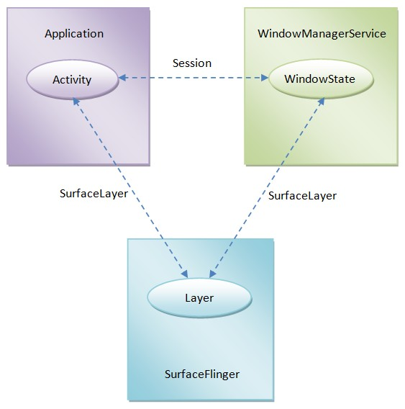

# WindowManagerService窗口管理机制

WindowManagerService服务除了要与Activity窗口所运行在的应用程序进程打交道之外，还需要与SurfaceFlinger服务以及窗口管理策略类PhoneWindowManager交互。

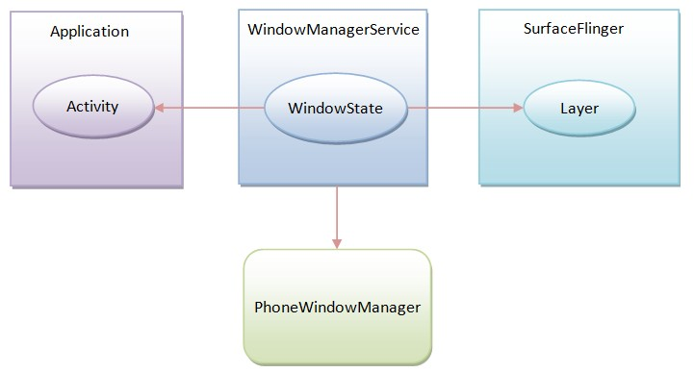

* 1. [窗口大小和位置（X轴和Y轴）的计算过程](http://blog.csdn.net/luoshengyang/article/details/8479101)

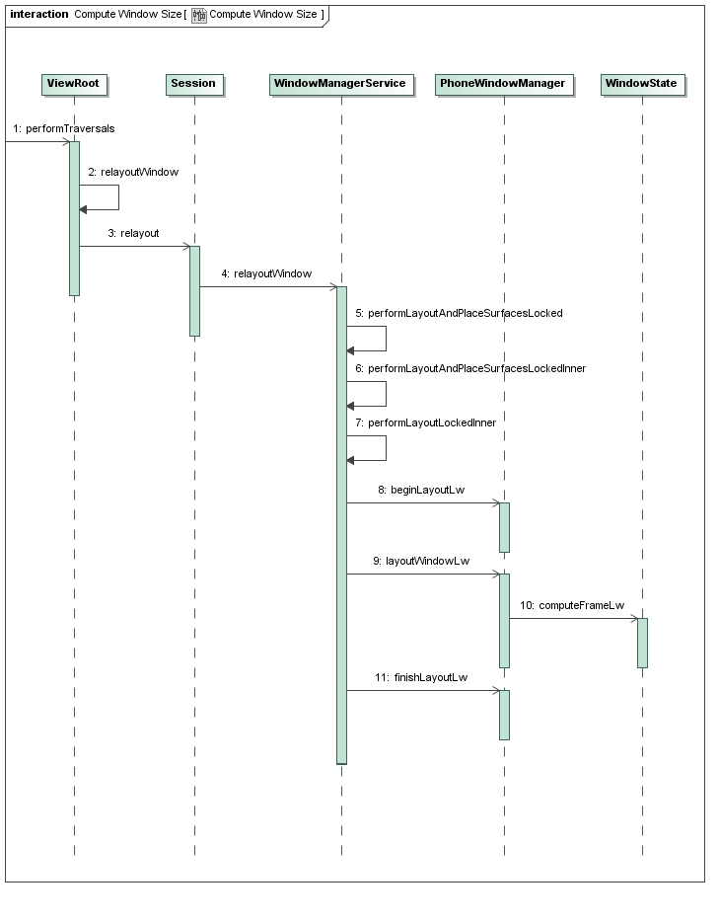

performTraversals

---> proc_create 创建/proc/fb目录

--- > register_chrdev 创建字符设备

--- > class_create 在/system/class下创建graphics目录

register_framebuffer 内核启动调用此函数

--- > do_register_framebuffer 注册帧缓冲设备

--- > device_create 根据主从设备号在/dev/graphics下创建设备

--- > fb_notifier_call_chain 通知控制台新的设备已经注册

--- > fbcon_event_notify

--- > fbcon_fb_registered

--- > fbcon_takeover(1) 显示第一开机画面

--- > take_over_console

--- > fbcon_init

--- > fbcon_prepare_logo

--- > fb_prepare_logo

--- > fb_find_logo

--- > fbcon_switch

--- > fb_show_logo

--- > fb_show_logo_line

--- >fb_do_show_logo

* 1. [窗口的组织方式](http://blog.csdn.net/luoshengyang/article/details/8498908)
  2. [输入法窗口的调整过程](http://blog.csdn.net/luoshengyang/article/details/8526644)
  3. [壁纸窗口的调整过程](http://blog.csdn.net/luoshengyang/article/details/8550820)
  4. [窗口Z轴位置的计算和调整过程](http://blog.csdn.net/luoshengyang/article/details/8570428)
  5. [Activity窗口的启动窗口的显示过程](http://blog.csdn.net/luoshengyang/article/details/8577789)
  6. [Activity窗口的切换过程](http://blog.csdn.net/luoshengyang/article/details/8596449)
  7. [Activity窗口的动画显示过程](http://blog.csdn.net/luoshengyang/article/details/8611754)

# Android系统开机画面显示过程

* 1. 第一开机画面显示

内核启动阶段显示第一开机画面

fbmem_init

---> proc_create 创建/proc/fb目录

--- > register_chrdev 创建字符设备

--- > class_create 在/system/class下创建graphics目录

register_framebuffer 内核启动调用此函数

--- > do_register_framebuffer 注册帧缓冲设备

--- > device_create 根据主从设备号在/dev/graphics下创建设备

--- > fb_notifier_call_chain 通知控制台新的设备已经注册

--- > fbcon_event_notify

--- > fbcon_fb_registered

--- > fbcon_takeover(1) 显示第一开机画面

--- > take_over_console

--- > fbcon_init

--- > fbcon_prepare_logo

--- > fb_prepare_logo

--- > fb_find_logo

--- > fbcon_switch

--- > fb_show_logo

--- > fb_show_logo_line

--- >fb_do_show_logo

* 1. 第二开机画面显示

Init进程启动是显示第二开机画面

Main init.c

---> queue_builtin_action(console_init_action, "console_init")

--- > list_add_tail(&action_list, &act->alist)

--- > execute_one_command

--- > action_remove_queue_head 从Action_list获取action

--- > cur_command->func 调用action方法

--- > console_init_action

--- > open(console_name, O_RDWR); 打开控制台

--- > load_565rle_image 显示第二开机画面

--- > fb_open 打开FB设备/dev/graphics/fb0

--- > android_memset16 将开机画面写入FB设备缓冲区

--- > restart_processes 重启需要启动的服务

* 1. 第三开机画面显示

第三个开机画面是由应用程序bootanimation来负责显示

init.rc / init.xx.rc

---> service surfaceflinger /system/bin/surfaceflinger

--- > main main_surfaceflinger.cpp

--- > sp<ProcessState> ps(ProcessState::self()) 打开binder

--- > new SurfaceFlinger()

--- > flinger->init()

--- > startBootAnim

--- > property_set("ctl.start", "bootanim")

Main init.c

--- > handle_property_set_fd 处理property改变

--- > handle_control_message 处理控制类型属性更改

--- > msg_start

--- > service_start 启动bootanim服务

--- > fork创建进程

--- > execve(svc->args[0], (char**) arg_ptrs, (char**) ENV)

--- > main （bootanimation_main.cpp）

--- > new BootAnimation()

--- > BootAnimation::onFirstRef

--- > run("BootAnimation", PRIORITY_DISPLAY)

--- > BootAnimation::readyToRun

--- > mZip.open(getAnimationFileName()) 打开动画文件

--- > BootAnimation::threadLoop

---> android()/movie()